
Visit mybenefits.metlife.com for quick and convenient account management or scan the QR code below.

Dental PDP Pus
Metropolitan Life Insurance Company

MetLife
PO Box 2006
Aurora, IL 60507-2006

00001

Thank you for participating in the Valdosta Board of Education MetLife Dental Plan, featuring the PDP Plus network.
What you need to know
With the MetLife Dental Plan, you can take advantage of benefits for you and your eligible dependents and the opportunity to save¹ on services including, discounts for staying in network―a savings of 30% - 45% for PDP Plus.
You and your eligible dependent(s) don’t need to present an ID card to confirm that you’re eligible for dental benefits.
What you need to do
To access important information regarding your dental benefits, register/log in to mybenefits.metlife.com or scan the QR code above. You can easily perform tasks, such as:
- Find a dentist/verify your dentist is an in-network provider
- Access & download digital ID card(s) to have on the go!
- Review coverage
- Estimate out of pocket costs
- Sign up for eAlerts and review claim status
We’re here to help
You can reach us at 800-942-0854. We’re available Monday through Friday, from 8 a.m. to 11 p.m. Eastern Time.
Below is your Dental Identification Card, available for subscribers only. While you’re not required to present this card to your dental provider as proof of coverage or confirm your eligibility, you may print this page and present it to your dental provider at your next appointment.
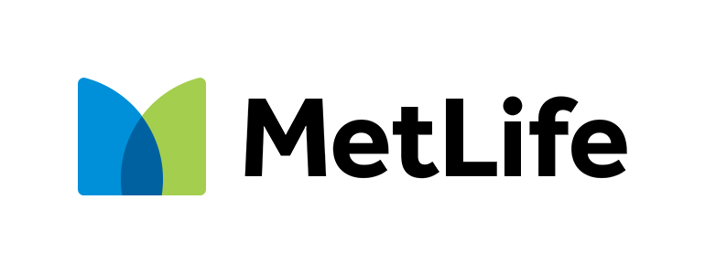

Questions and Answers

Valdosta Board of Education
273381
PDP Plus

Valdosta Board of Education
273381
PDP Plus

Insured Name:
Group Name:
Group Number:
Network:
Insured Name:
Group Name:
Group Number:
Network:
Fully insured – state regulated

Fully insured – state regulated

Dental PPO Plan

Dental PPO Plan

Obtain claim forms, review claim status, locate a dentist and view plan information online at mybenefits.metlife.com.
Mail completed claim forms to: MetLife Dental Claims,
PO Box 981282, El Paso, TX 79998-1282.
Contact MetLife at 800-942-0854
- Monday - Friday, 8:00am to 11:00pm EST to speak with
a customer service representative
- Confirm eligibility, order claim forms or request dentist directories
International Dental Travel Assistance call 1-312-356-5970 (collect)
Providers: 1-877-638-3379 (metdental.com)

Obtain claim forms, review claim status, locate a dentist and view plan information online at mybenefits.metlife.com.
Mail completed claim forms to: MetLife Dental Claims,
PO Box 981282, El Paso, TX 79998-1282.
Contact MetLife at 800-942-0854
- Monday - Friday, 8:00am to 11:00pm EST to speak with
a customer service representative
- Confirm eligibility, order claim forms or request dentist directories
International Dental Travel Assistance call 1-312-356-5970 (collect)
Providers: 1-877-638-3379 (metdental.com)

¹ Savings from enrolling in a dental benefits plan [featuring the MetLife Preferred Dentist Program] will depend on various factors, including the cost of the plan, how often participants visit a dentist and the cost of services rendered."

*Negotiated Fees refers to the fees that in-network dentists have agreed to accept as payment in full for covered services, subject to any co-payments, deductibles, cost sharing and benefits maximums. Negotiated fees are subject to change. Savings from enrolling in a dental benefits plan will depend on various factors, including the cost of the plan, how often participants visit the dentist and the cost of services rendered.

Group dental insurance plans featuring the Preferred Dentist Program are provided by Metropolitan Life Insurance Company, New York, NY.
Like most group benefit programs, benefit programs offered by MetLife and its affiliates contain certain exclusions, exceptions, reductions, limitations, waiting periods, and terms for keeping them in force. Please contact MetLife or your plan administrator for costs and complete details.
May I choose a non-participating dentist?
Yes. You can select the dentist of your choice. However, if you choose a non-participating dentist, your out-of-pocket costs may be higher as they haven’t agreed to accept negotiated fees. So, you may be responsible for any difference in cost between the dentist's fee and your plan's benefit payment.
Can I sign up to receive digital communications?
Yes. You can sign up for eAlerts and receive notifications of changes in your claim status. Simply, log in to mybenefits.metlife.com and update your communication preferences within your profile. Go green–opt in for paperless and view your Explanation of Benefits statements online at your convenience.
Do you offer language assistance services?
If you need interpretation services and are enrolled in a Preferred Dentist Program (Dental PPO) enrollees should call 1-800-GET-MET8 (800-438- 6388). For CA residents, these language assistance services are available to you at no additional cost.
Who is a participating dentist?
A participating dentist is a general dentist or specialist who has agreed to accept negotiated fees* as payment in full for covered services provided to plan members. Negotiated fees typically range from 30% - 45% for PDP plus below the average fees charged in a dentist’s community for the same or substantially similar services.*
Can I nominate a non-participating dentist?
Yes. You can recommend a dentist of your choice. There are two ways to nominate a dentist; you can either have your dentist visit metdental.com to apply themselves or you can provide MetLife your dentist’s information online at mybenefits.metlife.com and we’ll send them an application. Once you login to MyBenefits, select “Find a Provider”, enter your zip code, and click on “Nominate a Dentist”.

